Ujian Akhir Praktikum - Semester Genap 2019/2020
Practicum Final Exam - Even Semester Year 2019/2020
Matakuliah  Subject |  |  | ISYS6172 - Database Design |  |  | 
Kelas  Class | : | BA01 / BB01 / BC01 / BD01 / BE01 / BF01 / BG01 / BH01 / BI01 / BJ01 / BK01 / BL01 / BM01 / BN01 |  | Tanggal Mulai  Start Date | : 09 June 2020
Kelas  Class | : |  |  | Waktu Mulai  Start Time | : 11:20
Dosen  Lecturer | : | D1521 - Indrajani, S.Kom., M.M.  D3408 - Mediana Aryuni, S.Kom., M.Kom.  D4636 - Wihendro, S.Kom., M.M.  D4715 - Hendro Nindito, S.Si., MMSI  D4963 - Hanny Juwitasary, S.E., S.Kom., M.MSI. |  | Tanggal Selesai  End Date | : 10 June 2020
Dosen  Lecturer | : |  |  | Waktu Selesai  End Time | : 11.20

PERATURAN UJIAN:
Exam Regulations:
- Mahasiswa tidak diperbolehkan berdiskusi dan/atau bekerja sama dengan peserta ujian lainnya
Student is not allowed to discuss and/or work together with other exam participants
- Mahasiswa tidak diperbolehkan menyalin jawaban dari intenet
Student is not allowed to copy answer from the intenet
- Asisten BERHAK memberi nilai 0 (NOL) bagi peserta ujian yang melakukan segala bentuk kecurangan
Assistant is able to give 0 (ZERO) score for exam participant who does any cheating actions
- Kumpulkan jawaban tepat pada waktunya di https://laboratory.binus.ac.id/lab
Submit the answer on time at https://laboratory.binus.ac.id/lab
- Bila Anda tidak membaca peraturan ini, maka Anda dianggap telah membaca dan menyetujuinya
If you have missed to read these regulations, so you are considered to have read and agreed on it

SOFTWARE YANG DIGUNAKAN:
Software will be used:
- Microsoft Word Office 365
- https://app.diagrams.net

FILE YANG DIKUMPULKAN:
File must be collected:
- *.docx
- *.drawio
- *.png

PERHATIAN!
Attention!
- Bagi yang mengerjakan tidak sesuai dengan soal, maka akan diberikan nilai NOL (0)
For those who do not work in accordance with the exam case will be marked as ZERO (0)
- Bagi yang mengerjakan tidak sesuai dengan software dan versi yang telah ditetapkan, maka akan tetap dikoreksi dengan software dan versi yang telah ditetapkan
For those who do not work in accordance with the software and specific version will be corrected by the predefined software and version
- Kompres semua jawaban yang akan diunggah. Pastikan format pengumpulan nama file dan ekstensi sesuai dengan format berikut: [NIM]-[NAMA].zip
Compress all file that will be uploaded. Make sure the format for collecting file name and extension according to the following format: [NIM]-[NAME].zip

Soal
Case

SilverFox Fabric
SilverFox Fabric is a company that focuses on selling high-quality fabric to other manufacturers such as Kelvin Clein, Giordono, and M&H. As a developing company, SilverFox finds the need to implement a database system that can record a huge amount of data effectively and efficiently to compete, maintain, and operate the company in the best way possible. You as a data architect are requested to design the base model of the database by creating an ERD for the company. The company provides you with 2 documents which are their last selling invoice and the proof of payment of the invoice.
All fabric sales transaction that is recorded on SilverFox is calculated based on the fabric weight which is measured by Kilograms (Kg). The transaction will go through one of the sales staff who is responsible for all the transaction, an inventory staff whose job is to manage product traffic throughout the companies storehouse, a packaging/packing staff who is responsible to wrap, stack, and write all the necessary information on the packaging, and lastly a driver staff to deliver the purchased product to the customer.
There are 3 ways to pay your purchase on SilverFox Fabric which are Down Payment (DP), Partial Payment, and Full Payment. The payment can be paid at any given moment and can also be paid partially in installments. Once paid, the sales will give you a print of a document called Proof of Payment slip which records your date of payment, amount of money paid, the type of payment, and the transaction id that you are paying for. The slip will then be stamped and signed by the staff as proof that the slip is a genuine SilverFox document.

Sales Invoice
The Sales Invoice contains the transaction date, customer data, product data, contributing employee data, and the summary of the purchased product.

Proof of Payment
The Purchase Invoice contains the date from proof of payment, payment data, and the employee who processed the proof of payment for every printed slip.

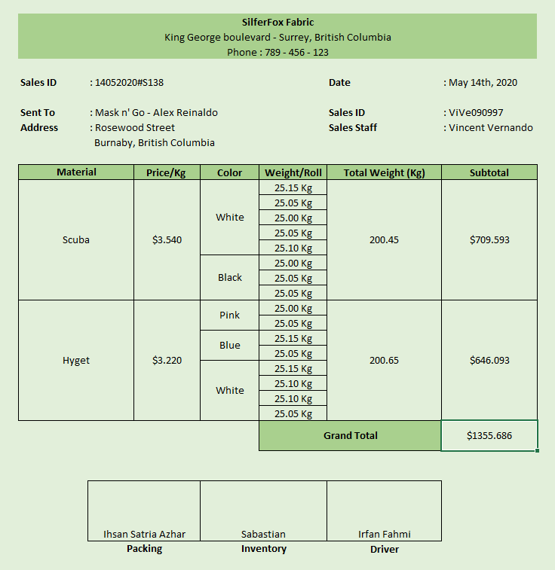
Figure 1. Sales Transaction Invoice

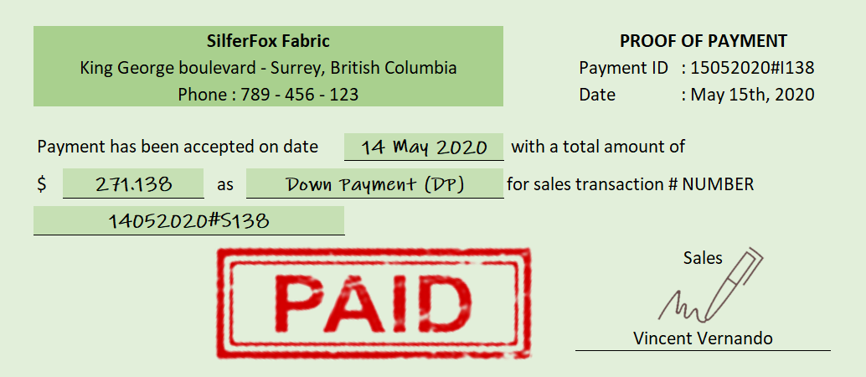
Figure 2. Proof of Payment

Tasks:
- From the above explanations and forms, you are required to:
- Create normalization for the Sales Transaction Invoice
- Create normalization for the Proof of Payment
- Create combined 3NF from the Sales Transaction Invoice and the Proof of Payment
- Create ERD from combined 3NF with its relationship.

NOTES:
1. Use only the data in the invoice for every UNF, 1NF, 2NF, and 3NF
2. For the ERD, please use draw.io website and save it in (*.png) and (*.drawio) format

Additional information:
  - Company name, address, and phone number should not be included in any part of the normalization.
  - Each Customer could have more than 1 company.
  - The product will always be delivered to the customer's company. Thus, is not stated in the document.
  - Each transaction will always be processed through 4 employees which are:
    - Sales
    - Inventory
    - Packing
    - Driver
  - The cost of one roll of fabric is determined based on the weight of each roll. The weight of every roll varies slightly from the other.
  - The price of each rolls is determined by the material of the fabric (Ex: nylon, silk, hyget, etc).
  - The company only accepts bank transfers as the payment method to the company's bank account. Thus, is not stated in the document.
  - All transactions can have more than 1 payment.
Example:
- Transaction A is paid once (1 full payment).
- Transaction B is paid 4 times (1 down payment, 2 partial payment, 1 full payment).
- Transaction C is paid 2 times (1 down payment, 1 full payment).
- Proof of payment and payment is 2 separate instances and may be printed on a different day.
Example:
- Transaction A is paid on the 10th of May. But the proof of payment is printed on the 11th of May due to the 10th being Sunday/National Holiday.
ATTENTION!
- ANY ADDITIONAL INFORMATION THAT IS NOT MENTIONED IN THE CASE, WILL REDUCE YOUR POINT.
- FEEL FREE TO ASK YOUR LAB ASSISTANT FOR FURTHER DETAILS REGARDING THE CASE (DO NOT MAKE ASSUMPTIONS)

